# **CHAPTER ONE**

## **1.0 INTRODUCTION**

### **1.1 Background of the Study**

An event refers to an occurrence happening at a determinable time and place. It is also something significant or notable that usually happens as a planned occasion or activity. Event planning is, therefore, the process of managing an occurrence or happening such as a party, tradeshow, ceremony, team building activity, or convention. Event planning entails budgeting, setting up timelines, selecting and booking the event sites, acquiring permits, planning for food, coordinating transport, coming up with a theme among others.

Event planning consists of coordinating every detail of meetings and conventions, from the speakers and venue to the organization of printed materials and audio-visual equipment. It starts with determining the objective that the sponsoring organization wants to achieve. Organizers choose a public address, entertainment, content and arrange the program to present the organization's information in the most efficient way. The organizers are responsible for selecting, prospective attendees and how to get them to the meeting.

Therefore, Event Planning is an uphill and demanding task. Planners must multi-task, face numerous deadlines and orchestrate the activities of many diverse groups of people. Organizers may need to travel extensively to attend meetings and to visit prospective sites and meet suppliers. Working durations can be irregularly wrong and working for more than 40 hours per week is common especially when the event is approaching.

Thinking of the hustles and baffles involved when one must go through when planning for an upcoming event, I have decided to come up with a system that immensely reduces these hustles. Through my study experience, I realized that in most cases occasions fail not because of inadequate funds but due to time constraints and lack of proper planning because of planning it manually.

**PROBLEM STATEMENT**

Events happen every semester and some students and staff are not aware of what is scheduled or happening in the University.

**PURPOSE**

The general purpose is to enable planning, manage and advertising events online.

**Specific Objectives**

The specific objectives of the Event Planning and Management System are to:

1. Enable those planning for events to do so easily, effectively, and efficiently.
2. Give users/students and staff an attractive, logical event advertising experience.
3. Enable event planners to monitor event engagement activities online.
4. Save time and other valuable resources for those planning and advertising events.

## **Justification**

Development of this system is justified because of the help it gives event organizers in planning and advertising events online quickly, efficiently, and more effectively.

**Scope/ Limitations**

The scope of the Event Planning and Management System is limited to only web-based programming and a working database in SQLLite.

**CHAPTER TWO**

## **2.0 LITERATURE REVIEW**

### **Literature review**

Event planning needs a digital platform where the university can plan and monitor their upcoming events online. In this regard, an excellent event planning and management system will: -

1. Deliver an attractive, logical event planning experience to engage users and improve relationships with students and staff.
2. Increase the audience through strategic notifications
3. Automate publicity management processes and free up time for staff or admin to focus on other aspects of their work.

### **Existing System**

Events that are organised need a lot of publicity and these involve manual work where one has to pin posters that might get washed away or plucked or covered by other posters but with the Campus event system this will all be in the past.

This describes how event planning can get to a whole new level of automation. The event planning system saves the users time, energy, and even resources that can be used meaningfully for other purposes.

**Methodology**

In the development of the requirement definition, data can be collected from a sample number of respondents using interview schedules, questionnaires, and observation techniques. One can also plan to develop a survey.

**System Design**

The major value of this application is to interface students and administrator. It gives a best interface to the students to see the details of events.

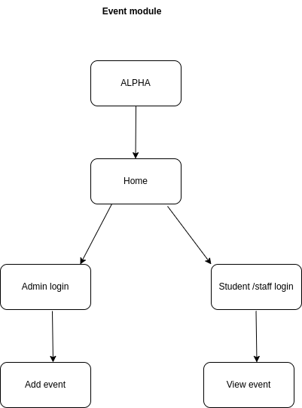

In this system there are two modules. One is student module and the other one is admin module. In admin module, admin can login by using login credentials like username and password. After logging in to the system some menu options will be seen like viewing the event data, event time table, event performance graph, and logout. Admin can upload the data, this is viewed by the student. Admin can generate the upcoming event, and the performance graph is generated based on the participation of students in specific departments.

In student module, student will register by providing details like roll no, first name, last name, registration number, and password. Student can login by using login credentials. Student can search the data according to event name or event description and also according to specific department. Student can see the upcoming event time table and performance graph.

